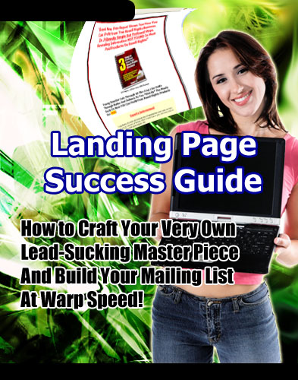

Landing Page Success Guide

By: [Insert Your Name Here]

LEGAL NOTICE

The Publisher has strived to be as accurate and complete as possible in the creation of this report, notwithstanding the fact that he does not warrant or represent at any time that the contents within are accurate due to the rapidly changing nature of the Internet.

The Publisher will not be responsible for any losses or damages of any kind incurred by the reader whether directly or indirectly arising from the use of the information found in this report.

This report is not intended for use as a source of legal, business, accounting or financial advice. All readers are advised to seek services of competent professionals in legal, business, accounting, and finance field.

No guarantees of income are made. Reader assumes responsibility for use of information contained herein. The author reserves the right to make changes without notice. The Publisher assumes no responsibility or liability whatsoever on the behalf of the reader of this report.

Table of Contents

Introduction to Landing Pages 5

The Landing Page System 6

What You Need Before Getting Started 8

Planning Your Landing Page Theme 9

How to Write a Landing Page that Converts 10

Tips on Increasing Your Landing Page Conversion Rate 12

Driving Traffic into Your Landing Page 14

Finest Examples of Landing Pages 16

Resource Guide 18

Bonus! 19

Landing Page Success Guide

Introduction to Landing Pages

Before you begin the attempt to build a successful list or create a powerful sales page, you will want to start with a rigorous introduction to landing pages. In stark contrast to undifferentiated, unfocused home pages, landing pages focus specifically on capturing leads for a newsletter or making sales for a specific product – and make no attempt to give visitors a different option.

Another common word that is often used to describe landing page, is “squeeze page” (or “lead capture page” in some circles). A squeeze page is a page designed to get names and email addresses. Usually, however, a squeeze page is usually a smaller type of landing page, which usually has an opt-in form in sight when the page loads.

So what is important to learn in an introduction to landing pages? First, it is important to recognize that all successful marketers use these. If you plan to sell a product over the Internet, you will want to use one, too, rather than relying on sidebar opt-in forms and unfocused pages that do not convey a single point and a single call to action.

Another important thing you will want to take away from this introduction to landing pages is that every landing page contains the same parts and is focused on a SINGLE goal – getting the visitor to become a subscriber or buyer.

These parts are as follows: an opt-in form (or sales prompt), a brief or lengthy introduction, a picture of the list/product owner, the signature of the list owner, and a call to action (or multiple calls to action).

Determining which model will work best for you can simply only be done through testing. While many boast a conversion and attribute it to the shortness of their introduction (many will be one short paragraph), otherwise will boast a high conversion rate because they use lengthy, thorough, and compelling copy.

If there is anything you absolutely must take away from an introduction to landing pages, it is that you cannot create a landing page or squeeze page that isn't focused.

The Landing Page System

The landing page system provides a uniquely powerful system through which you can derive profit from multiple streams. This article will briefly discusses some of those different streams – and how you can manipulate them.

Let's start with the landing page itself: all traffic is sent to the landing page. From there, it will have a number of options, depending on what you have given them. Many marketers suggest that your landing page should always be an opt-in form. Others will suggest that it should simply be a sales page.

Whether it's a free newsletter or a product for sale, the landing page system you create should include a “one time offer,” which will compel them to take action – subscribe, buy, etc.

Once they subscribe or buy, the landing page system you create should then re-route them to a thank you page, which opens up more means through which you can up-sell. One quick way to up-sell is to simply include advertisements on your thank you page for related affiliate products or for your own products. Here, again, you will want to give them a one-time offer.

Also, if you haven't yet asked them to join your mailing list, this is where you should do it – on your thank you page. Once they opt-in to your list, you now have a whole new option you can use in conjunction with the landing page system to generate revenue.

One such option is selling ad space in your newsletter or e-zine. The more people you have reading your newsletter, the more you can generally charge for ad space; however, you will want to avoid overselling to your list to ensure your advertisers actually make money.

Your next option is to endorse a product as an affiliate. You can tell your subscribers how someone has just created a brilliant product – and you can offer it to your subscribers through an affiliate link. You may even want to use other products you have has bonuses to give them something extra.

The last and most profitable way in which you can generate revenue through your newsletter is by creating and selling your own products to them.

It is important to note that you don't have to use all of these means to generate revenue; however, the more you use, the more you earn in general.

Your Landing Page
Your One Time Offer
(OTO)

Subscription to your Mailing List
Sell Ad Space in Your eZine

Endorse as an Affiliate

Thank You Page

Back-end Ads & Selling

Sell your own product

What You Need Before Getting Started

Before you get started building your landing page, you will need a number of things to a) make your offer actually have a point; and b) facilitate the creation of your landing page.

One thing you absolutely must have before you get started is an auto responder. Without any auto responder, you are tossing potential bags of money in the garbage. Rather than creating a relationship with customers and potential customers – and giving yourself the opportunity to attempt future up-sales -- you're allowing them to leave and never return.

In addition to an auto responder, you will need to have an actual offer that people want to buy. You may want to develop a product, such as an E-Book or a piece of software.

If you don't have the skills to do either, you can always hire a professional to do it for you through Elance.com or Guru.com. You will then either want to sell this product and attempt to get subscribers from your thank you page – or you will want to get subscribers by offering the product for free (which is what many Internet marketers now do).

Another thing you absolutely must have before you get started is a check out service. You may want to consider Paypal, Click Bank, or 2 Check Out. All of these services will allow you to make transactions quickly.

Another thing you must have before you get started is a set of graphics, which usually includes a graphic header, a check out button, background wallpaper, and a half-decent picture of yourself. You can probably provide the picture of yourself, but you might want to hire a professional to do the rest.

Another thing you will need before you can get started on your landing page is some way in which to create a realistic signature. http://www.vletter.com is probably your best bet; but, if you're on a budget, you may want to opt for simply using a word processing program.

Planning Your Landing Page Theme

Perhaps the most important part of creating a landing page is planning your landing page theme. How you select your theme, of course, will all depend on how you plan to generate traffic.

If you decide to generate traffic through search engine optimization, planning your landing page theme will entail finding phrases within your niche which have a high demand (aggregate search value) and a low supply (small amount of competing sites) and then creating multiple landing pages, each which is optimized around a different phrase.

If, on the other hand, you decide to generate traffic through pay per click (PPC) programs, such as Adwords, planning your landing page theme will again entail tuning a number of different pages to fit the keywords you are purchasing.

This is actually where most people fail when they create a landing page: they don't tune it to fit a specific audience. For instance, in the case of a squeeze page for a newsletter, they might start a newsletter about toys, but they only create one landing page and send all traffic to it. This is a big mistake.

Chances are, if you create a quality product or newsletter, it can benefit a number of people. So why not communicate the exact benefits they will derive from subscribing or buying?

If, for instance, you have a newsletter about Legos and toy blocks, so you group it under the loose heading of “toys,” a visitor who is looking specifically for information about either Legos or toy blocks will click off your page if they don't see the direct connection to the exact topic for which they were searching.

Instead, you will want to setup a page centered around Legos and a page centered around toy blocks. On each page, you will want to communicate the specific benefits to joining the list for each of those groups of visitors.

Going one step further, in addition to planning your landing page theme, if you are creating a landing page for a newsletter, you may also want to segment your list, so you can send information specifically about Legos to those who request it – and information about blocks to those who request it.

How to Write a Landing Page that Converts

Most people have no (or simply the slightest) idea how to write a landing page that converts. Instead, they slop together elements that they have seen used in other landing pages – but usually do not put them together in the same way the owner of the successful landing page did.

One major problem is copy. And that's fine. Not everyone is going to be an excellent writer – never mind a copywriter. But as someone selling a product or trying to build a list, it is important that you know your strengths and weaknesses – and that you either spend the time to overcome them or hire someone else to do it for you.

With copywriting, for instance, it is important to use a mix of compelling sales points with powerful psychological triggers. Most people who create a sales page miss either one or both of those elements.

For instance, they might concentrate so much on building hype that they don't actually explain what solution they are providing – and for whom they are providing it. If I don't have a specific problem that your product solves, why would I buy it? I wouldn't.

Now, if they fail to sprinkle in psychological triggers, such as “scientifically proven,” “guaranteed,” and “shocking,” no one will feel compelled to continue reading, as the benefits will have a low or average perceived value.

In addition to these two problems, some sales pages lack coherency and direction. The copy looks amateurish and it doesn't slowly grind forward, breaking down the visitor's resistance to the sale – and compelling him or her to buy more and more at each sales point.

Additionally, if there aren't multiple calls to action – another form of psychological trigger – then a potential visitor might never feel compelled enough to pull out his or her credit card on the spot and make the purchase.

In addition to careful copywriting, there are other important things you must take into consideration when writing a landing page that converts. For instance, it is important to build a compelling case for a time-bound offer.

Now, this doesn't mean you have to invent fake deadlines and constantly revise them each week. This is a good way to guarantee your complete loss of credibility in the shortest amount of time possible.

However, when planning your copy, you will want to make sure that you constantly urge the reader to act immediately by inserting a number of “calls to action,” as I've mentioned previously.

You may want to consider using fly-ins or pop-ups to create more urgency – or to make a time-bound offer. Perhaps you can use a countdown to build urgency (i.e., when someone arrives at your landing page, they have five minutes to purchase the product at the lowest price).

Now, if you're creating a squeeze page, you might want to employ slightly different tactics. Rather than building a compelling case with multiple triggers and calls to action over the course of 1000 words, you may want to simply condense that all into a compelling headline and one paragraph of “benefits.”

For a completely free-to-join squeeze page, you more than likely wont have a considerable amount of resistance to joining, unless the visitor:

- Doesn't see any benefits; and
- Suspects that you will sell their email address to spammers.

Both of these problems are relatively easy to overcome. In your headline, simply state the exact benefits they will receive for joining – as always, mixing in psychological triggers.

In your first paragraph of copy, give them a compelling reason to join now (i.e., the price might go up, the list might become private, you'll get this amazing report).

Now, to overcome the second problems, simply include a short line under your opt-in form that explains that you will not – under any circumstances – spam them or sell or give away their email address and name.

Tips on Increasing Your Landing Page Conversion Rate

There are three major ways in which you can create your landing page conversion rate. All landing pages created by professionals usually include these three elements at a few others.

The first way in which you can increase your conversion rate is through personalization. This is usually done in two ways: the first way is by providing a photo of yourself. The second way is by adding your signature to the bottom of your landing page.

This radically increases visitors' trust. Most people who resist buying products online do so because they're weary of getting scammed by a faceless liar, who wont be around when they need help or when they need to return the product.

Tip: By adding your picture and signature, you can significantly increase a gain in your visitors' trust. ☺

Another way in which you can increase your landing page conversion rate is by using black text or a white layout. Regardless of what anyone tells you, this is one of the easiest ways in which to make your page look professional, rather than pathetic or desperate.

The third way in which you can gain trust is by offering something for free. This is generally what you will do if you're using a squeeze page to generate leads: you'll offer a free report or five-day course – and then use that to generate leads, which you will later up-sell or generate revenue from via affiliate sales. Why is this technique so effective?

Quite simply because it allows them to judge your work and ideas before they actually have to pay for them. Additionally, it builds trust.

In addition to these three general ways in which to increase your conversion rate, you should always guarantee a product. If you sell through Click Bank, you actually wont have a choice.

But if you're using Paypal or some other check out (Credit Card processing) program, you will want to make sure you clearly state that customers can return your product for any reason within a given period of time after the purchase.

Follow all of these steps and you will significantly increase your landing page conversion rate.

Driving Traffic into Your Landing Page

Driving traffic into your landing page – it sounds easy, doesn't it? Well, it's not. And no matter how great your landing page is, it wont matter if no one ever reads it. Furthermore, if everyone in the world other than your target audience reads it, it also wont matter. This is why you need to find media through which you can drive targeted visitors to your landing page.

One way in which you can drive traffic to your landing page is through natural search engine optimization. This is the slowest process, but it is also one of the best ways to ensure a continually increasing stream of traffic over time.

Generating natural search engine traffic generally entails getting links to your site. While reciprocal linking was once the best strategy, experts now believe that major search engines are devaluing reciprocal links in favor of one-way links and triangular links (which search engines can't really detect).

Another way in which to get natural search engine traffic is by optimization your website for certain key phrases. You can do this by creating pages that specifically focus on one keyword on your given niche. You can then set the page extension to that keyword and optimize the content at a 1.5% density for that keyword. You will also want to use it in header and title tags.

Now, in addition building natural search engine traffic, you will want to consider using pay per click advertising. You can do this by opening an account with Google Adwords.

As mentioned earlier, successful Google Adwords campaigns do two things: they group keywords into multiple, small, related groups – and they send leads to multiple, tweaked landing pages.

This means you will have to start with some careful keyword research; and you will then have to alter your landing pages to match that research. These are some of the most commonly used tools for driving traffic to a landing page; however, they are not always the most effective.

Now, both of those methods can be effective, but they both usually have rather high barriers to entry and require a lot of work.

Luckily, you do have another option: human connections. And this is where most Internet marketers fail. They don't realize the power of human connections because they are so caught up in the idea of making transactions and collecting massive checks without having to deal with customers and clients.

One quick way to get traffic through human connections is a joint venture. You can enter into a joint venture by compiling a list of possible “partners” -- or people who might be able to assist you in some mutually-beneficial way. This list might include other list owners in your niche, site owners in your niche, and experts.

There's only one important thing you should keep in mind when contacting joint venture partners – and that is to make it as quick, easy, and beneficial for them as possible. If they have no incentive for doing it, they probably wont even reply to you. And if it isn't easy, they'll accept other joint venture offers over yours.

Another way in which you can drive traffic to your landing page is through blog and forum posting; however, it is important that you do not spam, as many businesses do. Instead, actually participate on the forum, provide people with something of value; and, after a while, post your product in your signature – and try to network with people on the forum who work in similar fields.

Your approach to blog posting should be similar. Include a signature file that links back to your landing page, but don't spam. Instead, post useful comments. This is not only more ethical, but it is plainly more effective. Spam gets deleted. Good comments get praised, inducing people to follow your link and check out your products.

Finest Examples of Landing Pages

http://www.ebizmodelsyoucancopy.com/resellrights

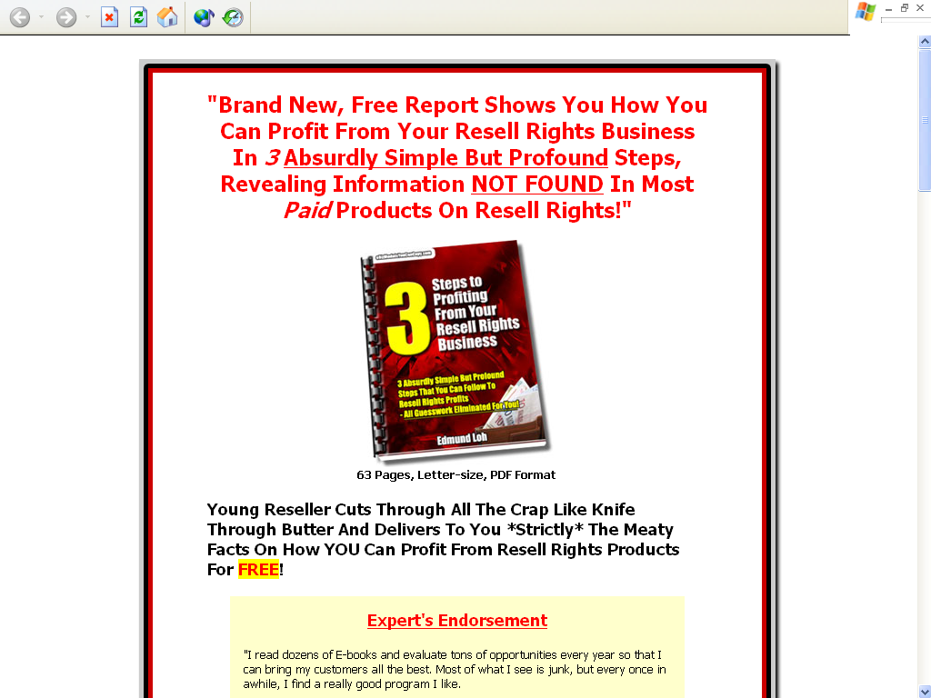

http://www.privatelabelrightsgold.com/

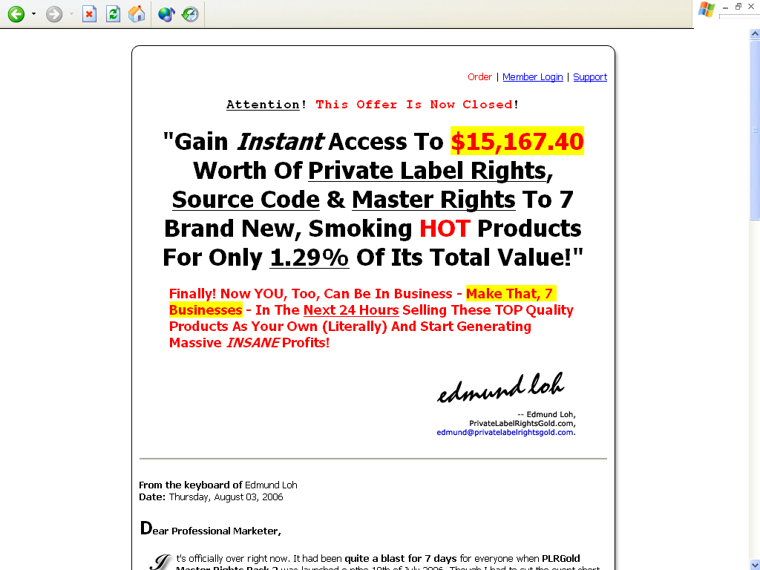
http://www.selfimprovementnewsletters.com/

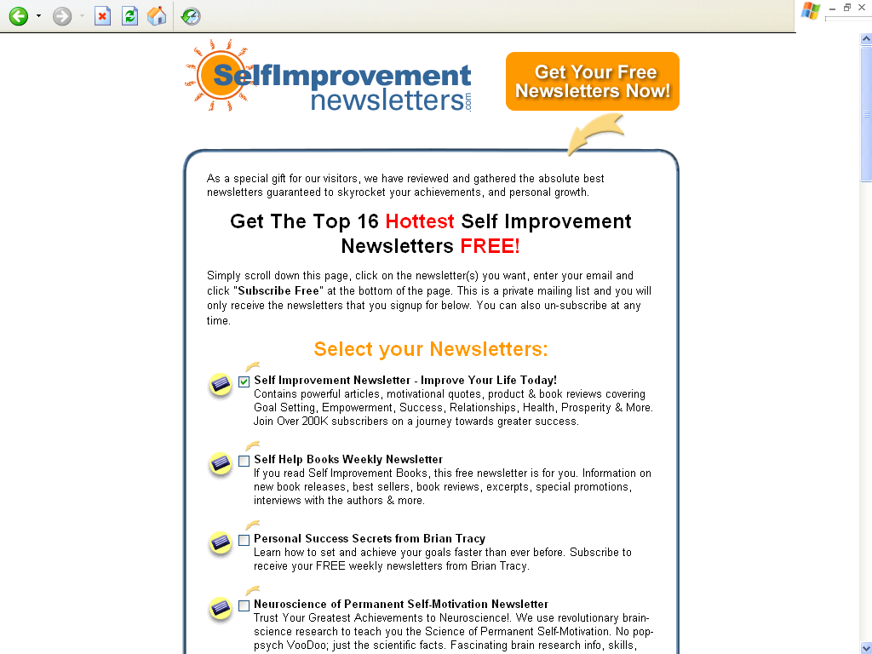

http://www.doubleyourdating.com/dt



Resource Guide

Recommended Reading

3 Steps to Profiting From Your Resell Right Business – how to profit from buying and reselling digital products in 3 absurdly simple but profound steps, NOT FOUND in most PAID products!

Edmund Loh’s Guide to Private Label Rights – your essential guide to buying and selling Private Label products in the Internet marketplace. This is one of the earliest and often updated manuals on Private Label Rights in the Internet Marketing community!

19 Internet Business Models – eliminate guesswork and discover what makes the world go round for Internet Entrepreneurs and copy their success business systems for your own in a flash – low cost, high profit!

All-in-One E-Commerce Solutions

SOLOBIS – all-in-one solution comes with unlimited web hosting, domain name, unlimited auto responders, broadcast feature, custom web builder, file manager, link cloakers, JV manager, 500+ beautiful web templates, online support team, and many more. No HTML and programming knowledge required.

Recommended Payment Processors

PayPal – the most used and recognized merchant in the Internet marketplace.

2CheckOut.com – start accepting credit card payments from customers from several parts of the world! If you are staying in a country where you cannot accept PayPal and/or ClickBank payments like me, I recommend this.

Congratulations!

“Your Purchase of this Book Entitles You to a FREE Lifetime Membership Privileged Access to ResellRightsMastery.com As a Gold Member… Worth $197.00!”

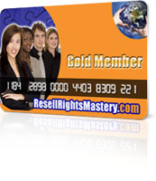
From: [Insert Your Name Here]
To: You!

Dear Valued Reader,

I would like to invite you to join my active membership site, ResellRightsMastery.com, as a privileged Gold member! Your Gold member benefits entitle you to:

- Consistently adding collection of Resell Rights items you can sell and pocket all the sales,

- Adding array of Private Label articles you can edit, put in your resource box, compile into Info products, and submit to article directories for exposure,

- Up to 10 auto responder accounts you can use to collect leads and build your mailing list for your Internet Business,

- Advanced Reseller strategies issues on how to gain all the edges as a reseller,

- And much, much more!

This membership access is valued at $197.00 but as a gesture of thanks for joining me in this short, fast but thrilling adventure through the pages of this book, this membership privilege is yours $197.00 FREE of CHARGE. Consider it a bonus, but you’ll want to be connected to the Internet right now to take advantage of this bonus!

So get connected to the Internet if you haven’t just yet, and click on the link below to sign up – no catches!

Click Here to Join ResellRightsMastery.com as a Gold Member FREE

This is my way of saying thanks and I look forward to your joining in ResellRightsMastery.com! ☺

Warm Regards,

[Insert Your Name Here]

P.S. Once you’re inside the member’s area, you’ll discover all the possibilities of building your Internet Business on steroids.

